1. **String conversion from upper to lower and vice versa.**

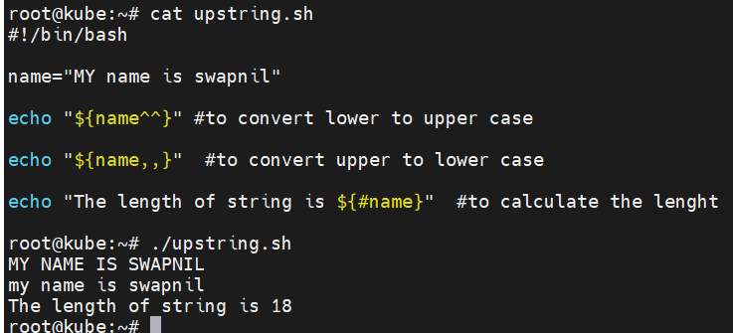

1. **String manipulation.**

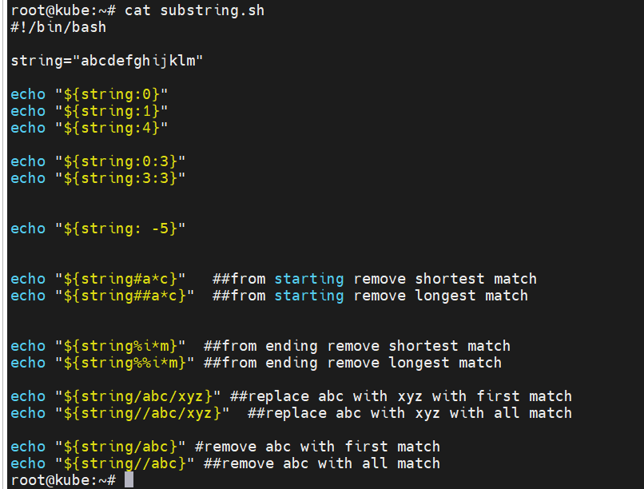

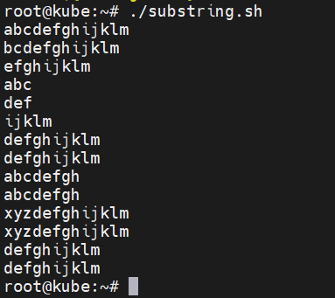

1. **Set default value**

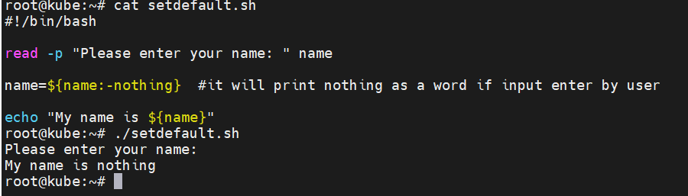

1. **Exit from script if variable value is not set or input not enter for variable.**

